**DB and Tables creation Lab**

1. Create the following database “using Wizard”:
   * Database Name: SD3x-Company
2. Create the following tables with all the required information and insert the required data as specified in each table using insert statements[at least two rows]:
   1. Table name: Department (Programatically)
      1. Columns:
         1. DeptNo: int , PK.
         2. DeptName: Nvarchar(20)
         3. Location: Nchar(2)
      2. Make the location column value ”NY” as a default value in case of user didn’t insert it.
   2. Create the following tables, and use Suitable data types and constraints: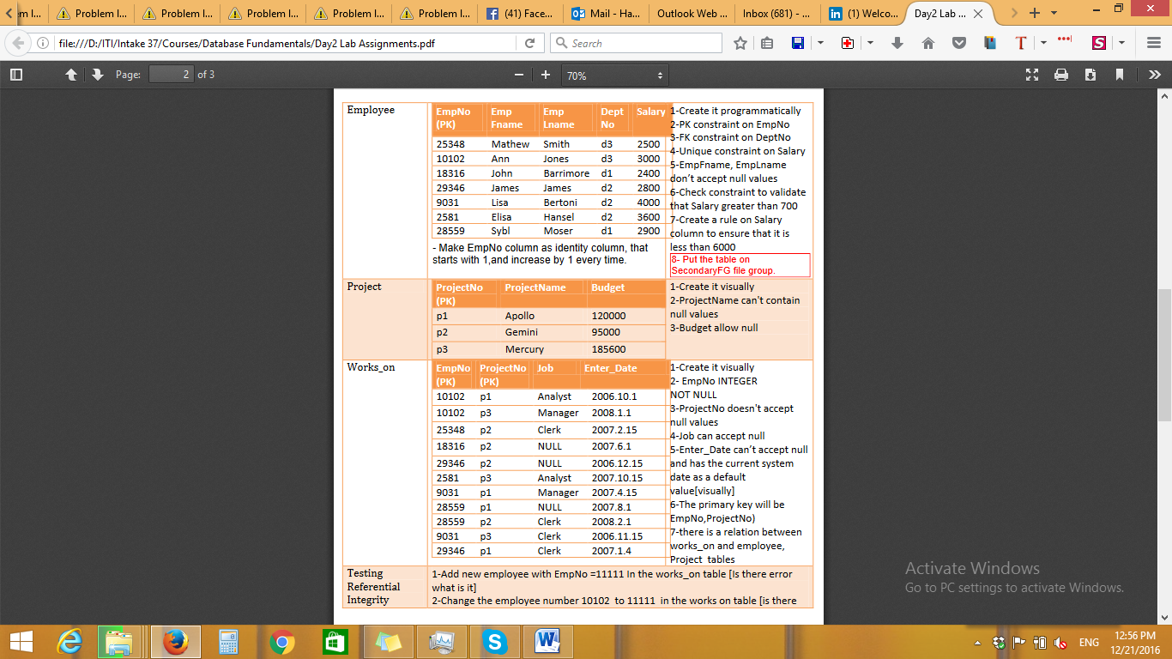
3. Modify the tables as following:
   1. Add TelephoneNumber column to the employee table[programmatically]
   2. drop this column[programmatically]
4. Create the following schema and transfer the following tables to it
   1. Company schema
      1. Department table (Programmatically)
      2. Employee table (Programmatically)
5. Delete the primary key of the Employee table. Why it will not work?
   1. Can a Primary key refer to Unique key instead of Foreign key?
6. Insert at least 3 records (Programatically) in each table from the data shown in the above image, and the other records you can insert them Visually.
7. Try update and Delete on the previous data.
   1. Testing Referential Integrity:
      1. Add new employee with EmpNo =11111 In the works_on table [Is there error what is it].
      2. Change the employee number 10102 to 11111 in the works on table [is there error what is it].
      3. Modify the employee number 10102 in the employee table to 22222. [is there error what is it].
      4. Delete the employee with id 10102
8. Display the constraints for the Employee table using 2 different methods (Bonus)